AWS Elastic Load Balancing

Starting Point
- A brand-new AWS account — no custom VPC, no Route 53 hosted zone, no EC2 instances exist yet.
- A domain already registered and paid for at GoDaddy (e.g., mylabsite2026.com), but its DNS is still managed by GoDaddy's default name servers.
- This guide builds every AWS resource required from that starting point, in order, so nothing is assumed to already exist.

What This Guide Builds
1. Foundational networking: one VPC with two public subnets across two Availability Zones and an Internet Gateway.
2. Domain onboarding: a Route 53 public hosted zone, with GoDaddy's name servers repointed at it.
3. A Classic Load Balancer, with its own backend instances.
4. An Application Load Balancer, with its own backend instances.
5. A Network Load Balancer, with its own backend instances.
6. SSL/TLS for the Application Load Balancer via AWS Certificate Manager.
7. A Route 53 record mapping the GoDaddy domain to the Application Load Balancer.
8. Application Load Balancer access logs delivered to S3.

Prerequisites
- Login credentials for the new AWS account (root or an IAM admin user).
- Login credentials for the GoDaddy account that owns the domain.
- An EC2 key pair for SSH access, created during Task 1's instance launch if one doesn't already exist.
Naming/CIDR plan used throughout this guide (adjust the domain to your own):
Resource | Detail
AWS Region | US East (N. Virginia) — us-east-1
VPC | Lab-VPC — 10.0.0.0/16
Public-Subnet-A | us-east-1a — 10.0.1.0/24
Public-Subnet-B | us-east-1b — 10.0.2.0/24
Domain | mylabsite2026.com (registered at GoDaddy)

PHASE 1: Create the VPC and Networking Foundation
Every load balancer and backend instance in this guide runs inside this VPC, so it is built once, first.

Step 1.1 — Set the Region
1. Log in to the AWS Management Console.
2. Region selector (top-right) → select US East (N. Virginia) us-east-1.

Step 1.2 — Create the VPC
1. Search for and open the VPC console → Your VPCs → Create VPC.
2. Select VPC only.
3. Name tag: Lab-VPC. IPv4 CIDR block: 10.0.0.0/16 (manual input). IPv6 CIDR block: No IPv6 CIDR block. Tenancy: Default.
4. Click Create VPC.
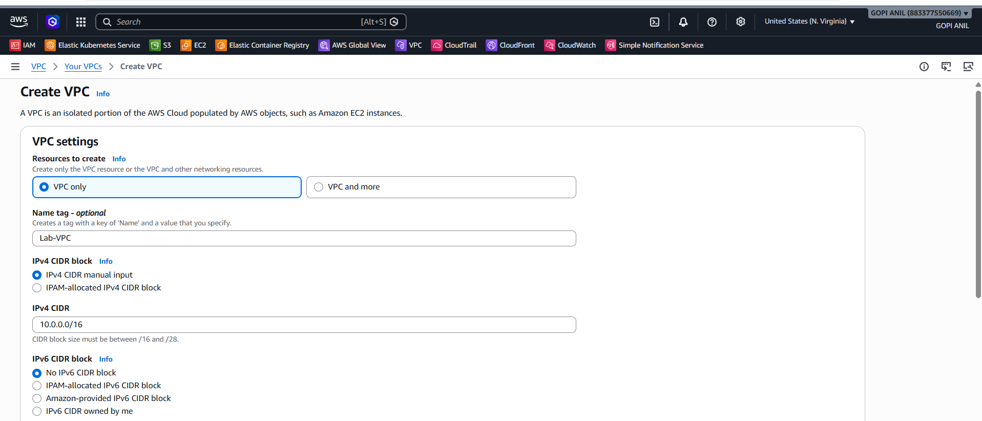
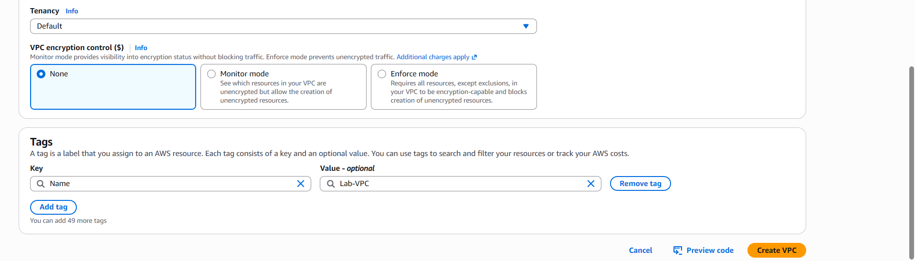

Step 1.3 — Create Two Public Subnets in Two Availability Zones
1. Subnets → Create subnet → VPC ID: Lab-VPC.
2. Subnet 1: name Public-Subnet-A, Availability Zone us-east-1a, IPv4 CIDR 10.0.1.0/24.
3. Click Add new subnet, then add Subnet 2: name Public-Subnet-B, Availability Zone us-east-1b, IPv4 CIDR 10.0.2.0/24.
4. Click Create subnet.
5. Select Public-Subnet-A → Actions → Edit subnet settings → check Enable auto-assign public IPv4 address → Save. Repeat for Public-Subnet-B.
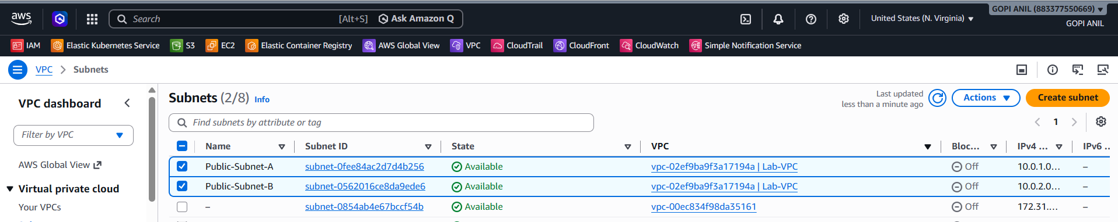

Step 1.4 — Create and Attach an Internet Gateway
1. VPC console → Internet Gateways → Create internet gateway. Name tag: Lab-IGW → Create.
2. Select Lab-IGW → Actions → Attach to VPC → select Lab-VPC → Attach internet gateway.
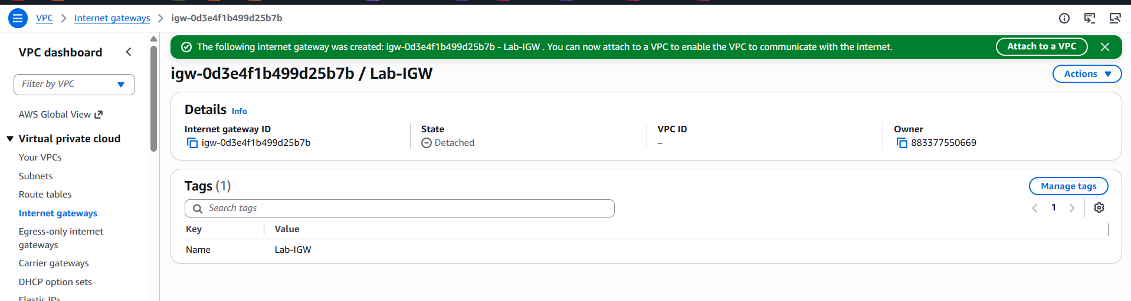

Step 1.5 — Create and Configure the Public Route Table
1. VPC console → Route Tables → Create route table. Name tag: Public-RT. VPC: Lab-VPC → Create route table.
2. Select Public-RT → Routes tab → Edit routes → Add route: Destination 0.0.0.0/0, Target = Internet Gateway → Lab-IGW → Save changes.
3. Subnet associations tab → Edit subnet associations → check both Public-Subnet-A and Public-Subnet-B → Save associations.
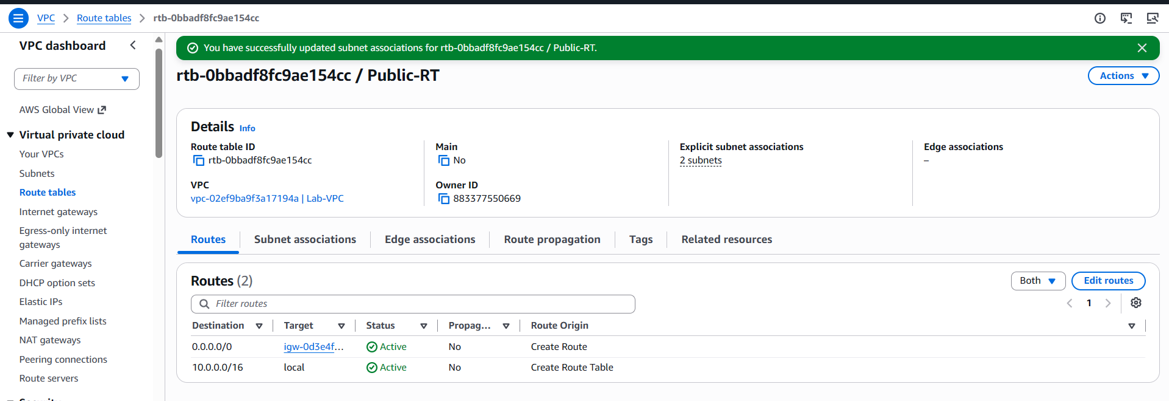

PHASE 2: Onboard the GoDaddy Domain into Route 53
This connects the domain already registered at GoDaddy to AWS DNS management, so Route 53 can later create records pointing it at the Application Load Balancer (Task 5) and validate the SSL certificate (Task 4).

Step 2.1 — Create the Route 53 Hosted Zone
1. Open the Route 53 console → Hosted zones → Create hosted zone.
2. Domain name: mylabsite2026.com (use your actual domain).
3. Type: Public hosted zone.
4. Click Create hosted zone.
5. Note the four NS (name server) records automatically created, e.g., ns-123.awsdns-45.com, ns-678.awsdns-90.net, ns-234.awsdns-56.org, ns-789.awsdns-01.co.uk.
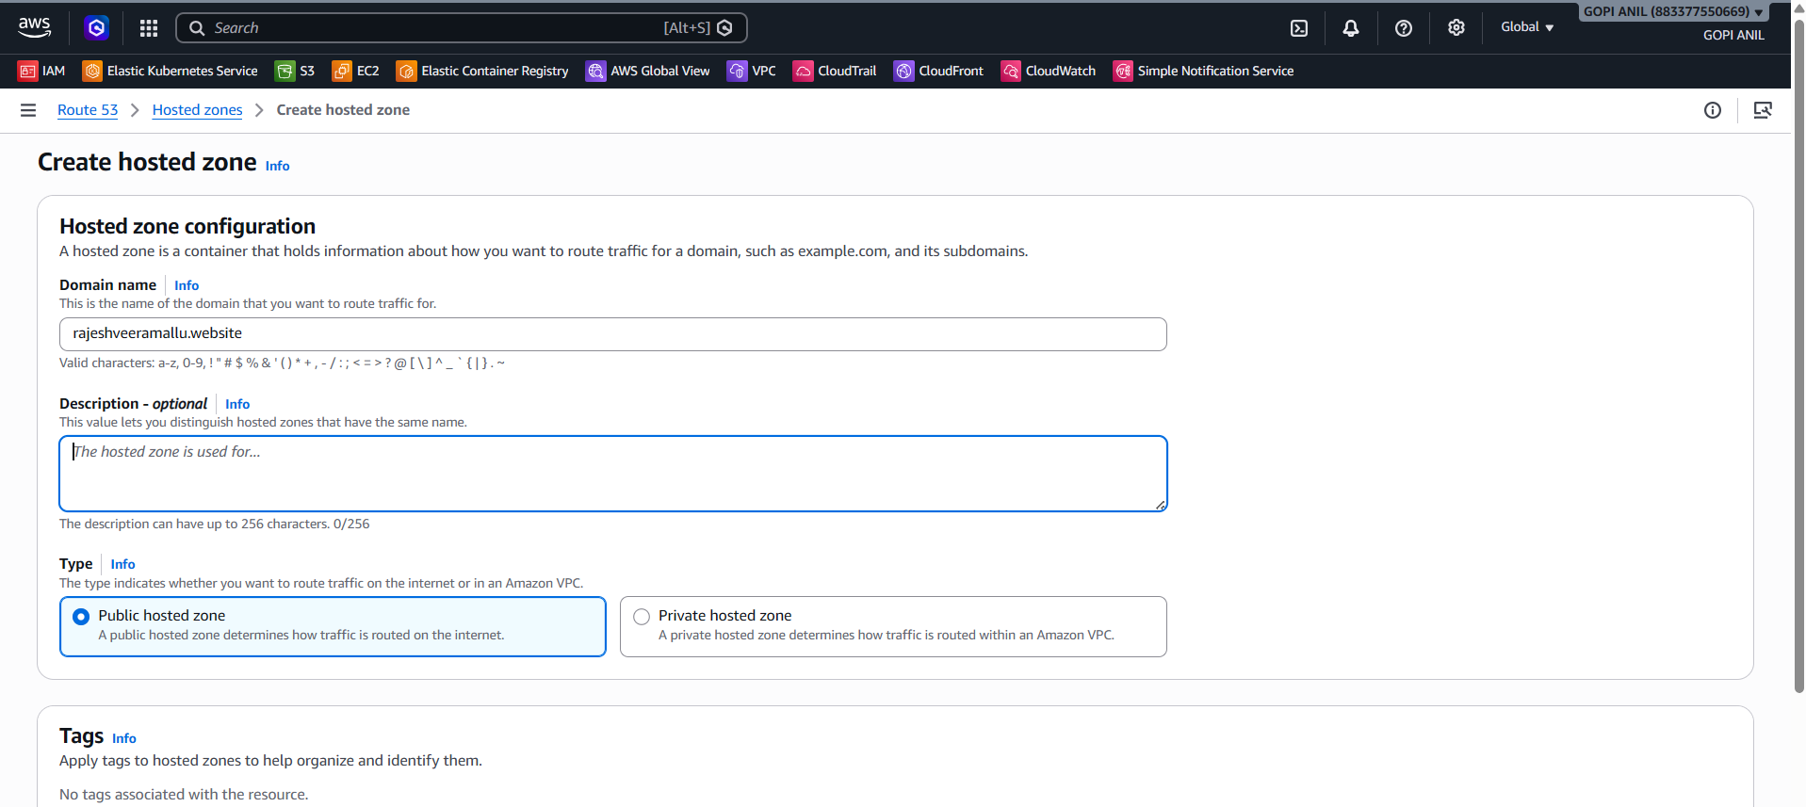
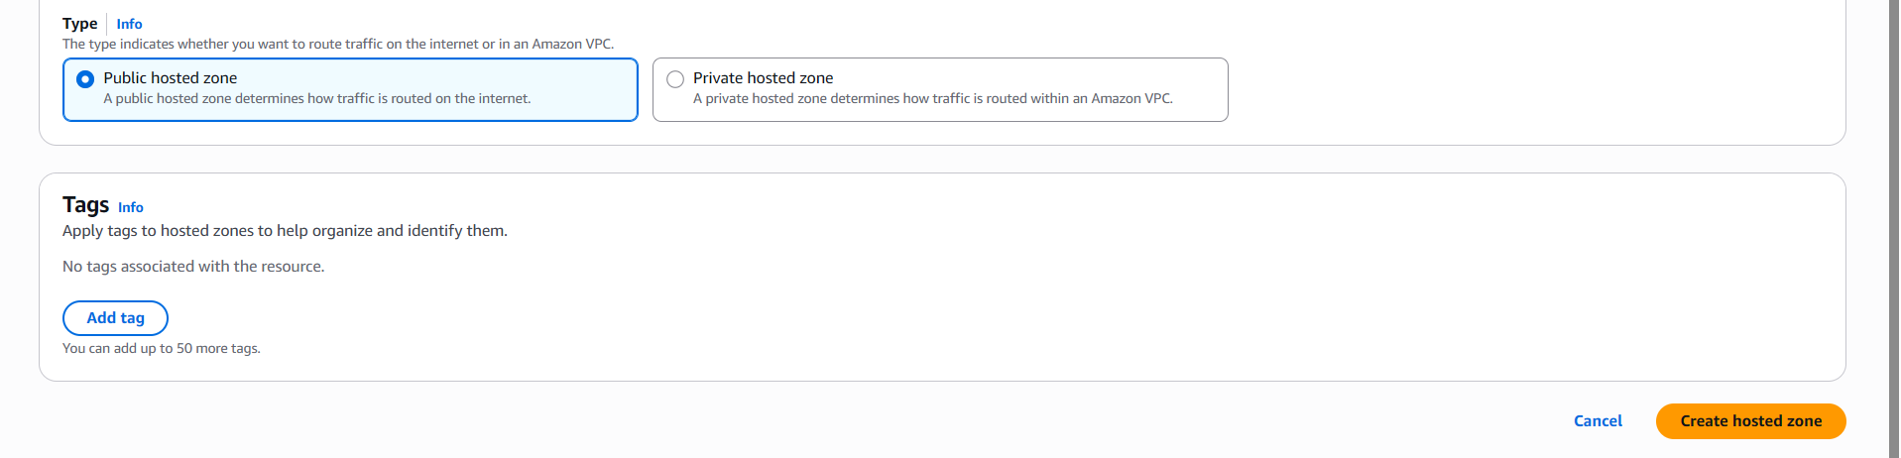
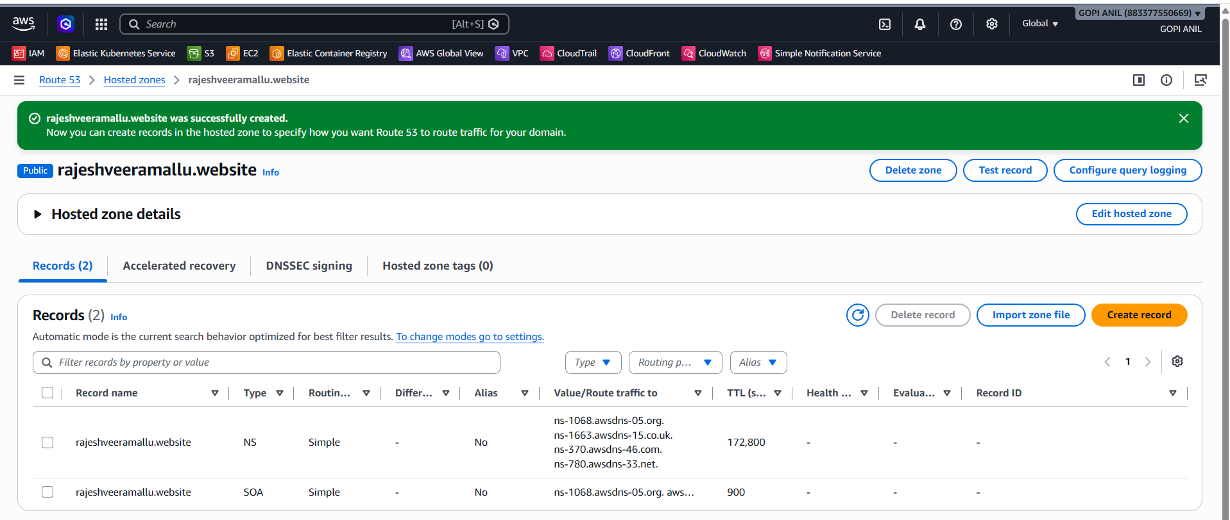

Step 2.2 — Point GoDaddy's Name Servers at Route 53
1. Log in to https://www.godaddy.com with the account that owns the domain.
2. My Products → Domains → select the domain → DNS (or Manage DNS).
3. Find Nameservers → click Change.
4. Select Enter my own nameservers (custom) / I'll use my own nameservers.
5. Enter the four NS values copied from Step 2.1, one per field, removing GoDaddy's default entries.
6. Save the changes.
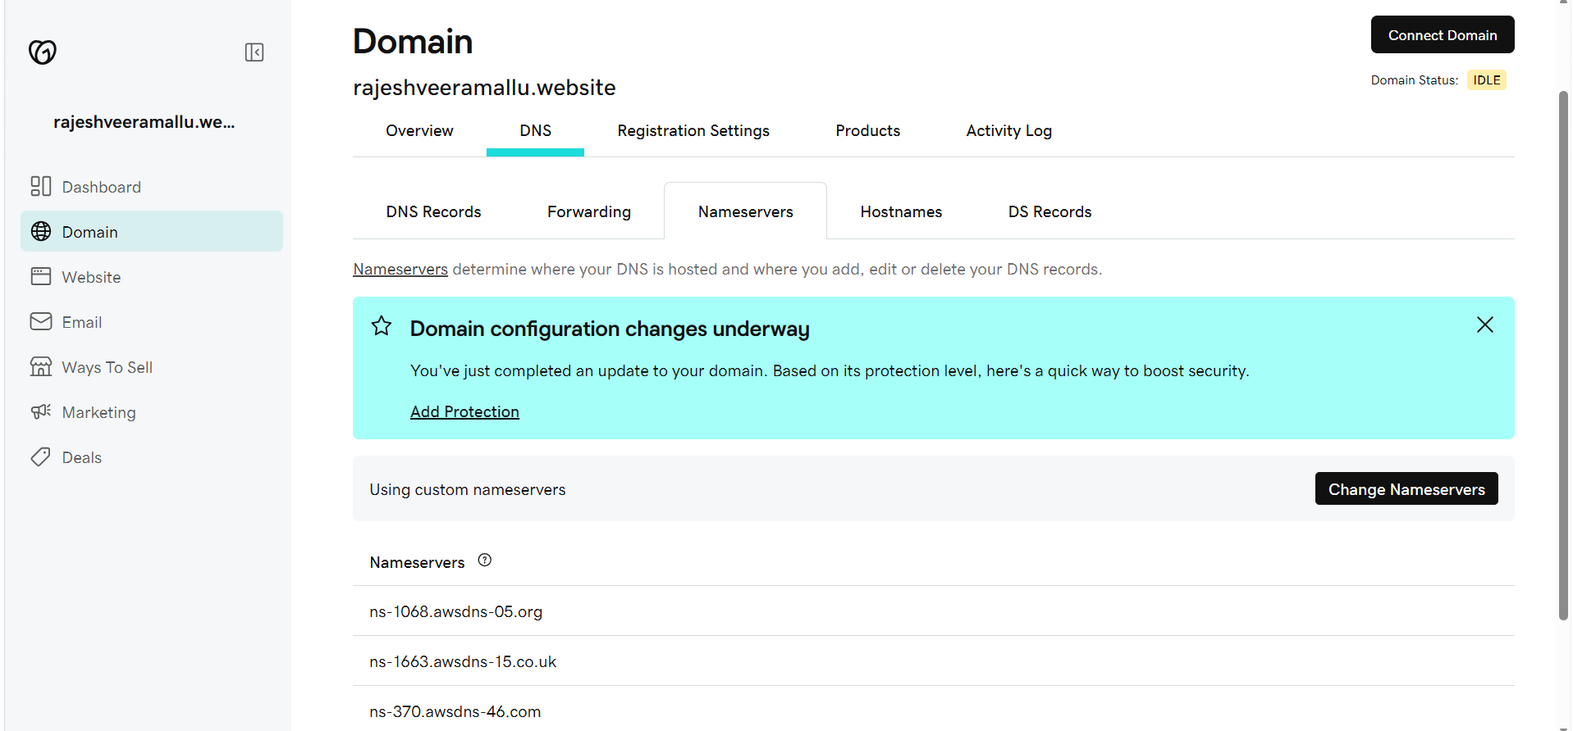

Step 2.3 — Wait for Propagation and Verify
1. DNS propagation for a nameserver change can take anywhere from a few minutes to 24–48 hours.
2. From a terminal, run: dig NS mylabsite2026.com (or nslookup -type=NS mylabsite2026.com) and confirm the returned name servers match the four from Route 53, not GoDaddy's defaults.
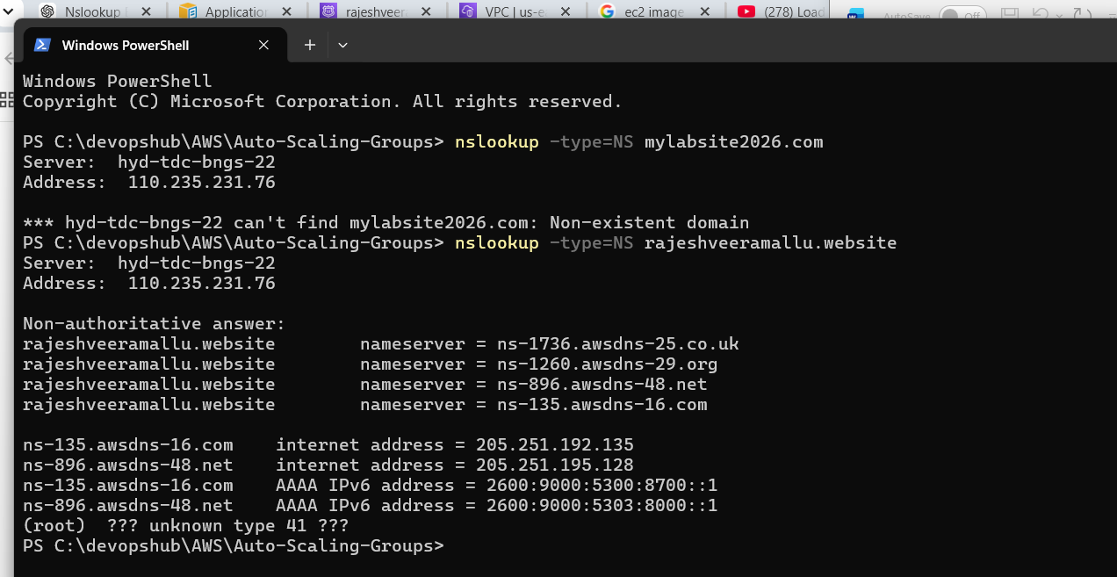

TASK 1: Configure a Classic Load Balancer
The Classic Load Balancer (CLB) is AWS's original load balancer type, operating at both Layer 4 and Layer 7. AWS recommends ALB/NLB for new workloads, but CLB remains available and is covered here for completeness/legacy-migration scenarios.

Step 1.1 — Create a Security Group for the Backend Instances
1. EC2 console → Security Groups → Create security group.
2. Name: Classic-Backend-SG. VPC: Lab-VPC.
3. Inbound rules: allow HTTP (80) from Lab-VPC's CIDR (10.0.0.0/16).
4. Click Create security group.
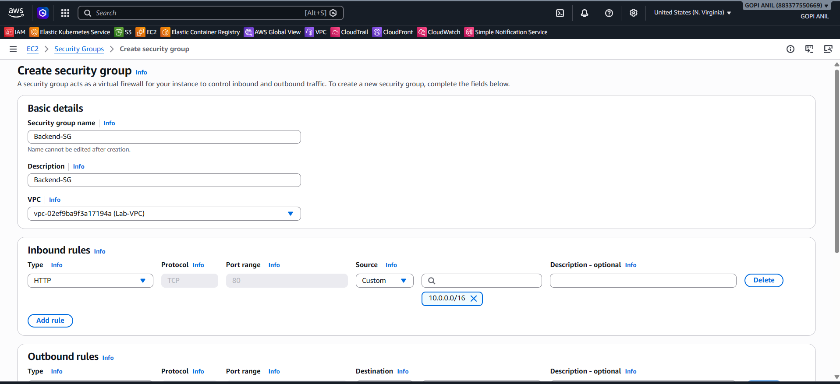
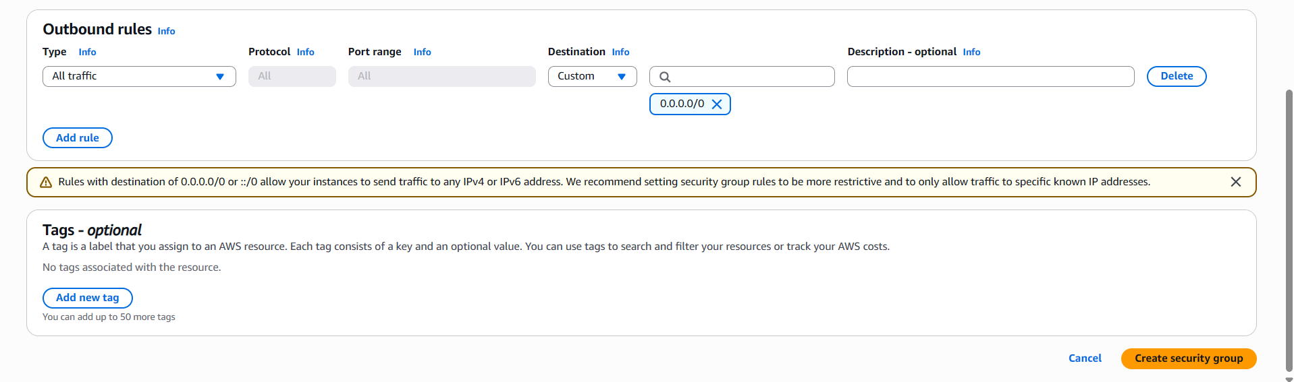

Step 1.2 — Launch Two Backend EC2 Instances
1. EC2 console → Instances → Launch instances.
2. Name: Classic-Web-1. AMI: Amazon Linux 2023. Instance type: t2.micro. Key pair: select or create one.
3. Network settings: VPC = Lab-VPC, Subnet = Public-Subnet-A, Auto-assign public IP = Enable, Security group = Classic-Backend-SG.
4. Click Launch instance.
5. Repeat, naming the second instance Classic-Web-2, placed in Public-Subnet-B.
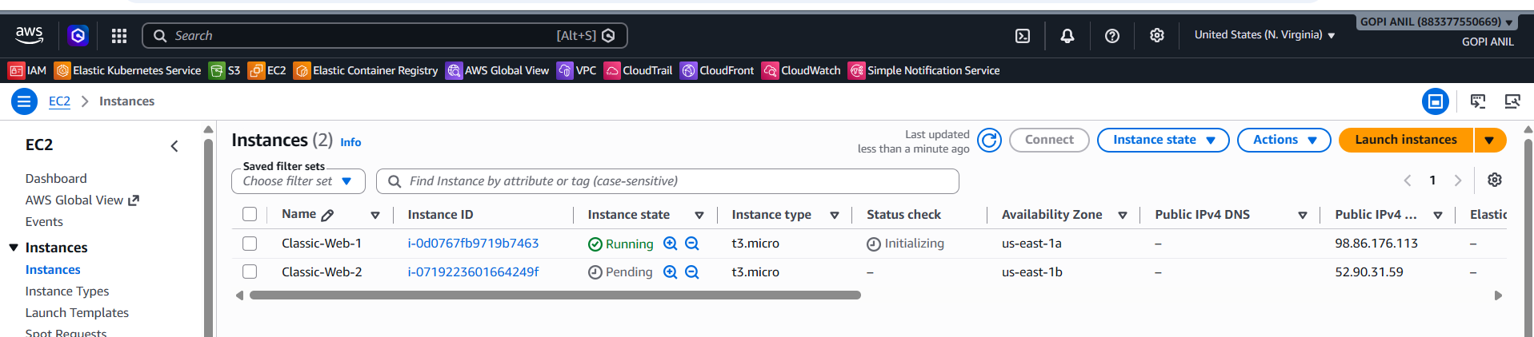

Step 1.3 — Install Apache on Both Instances
1. Connect to each instance (EC2 Instance Connect or SSH) and run:
sudo yum update -y
sudo yum install -y httpd
sudo systemctl enable --now httpd
echo "<h1>Hello from $(hostname -f)</h1>" | sudo tee /var/www/html/index.html
2. Confirm both instances show Running and pass EC2 status checks.
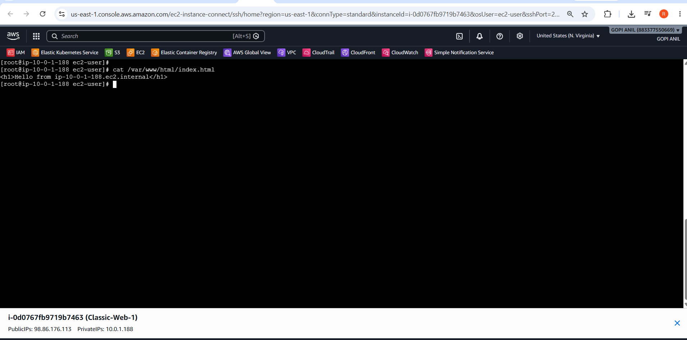
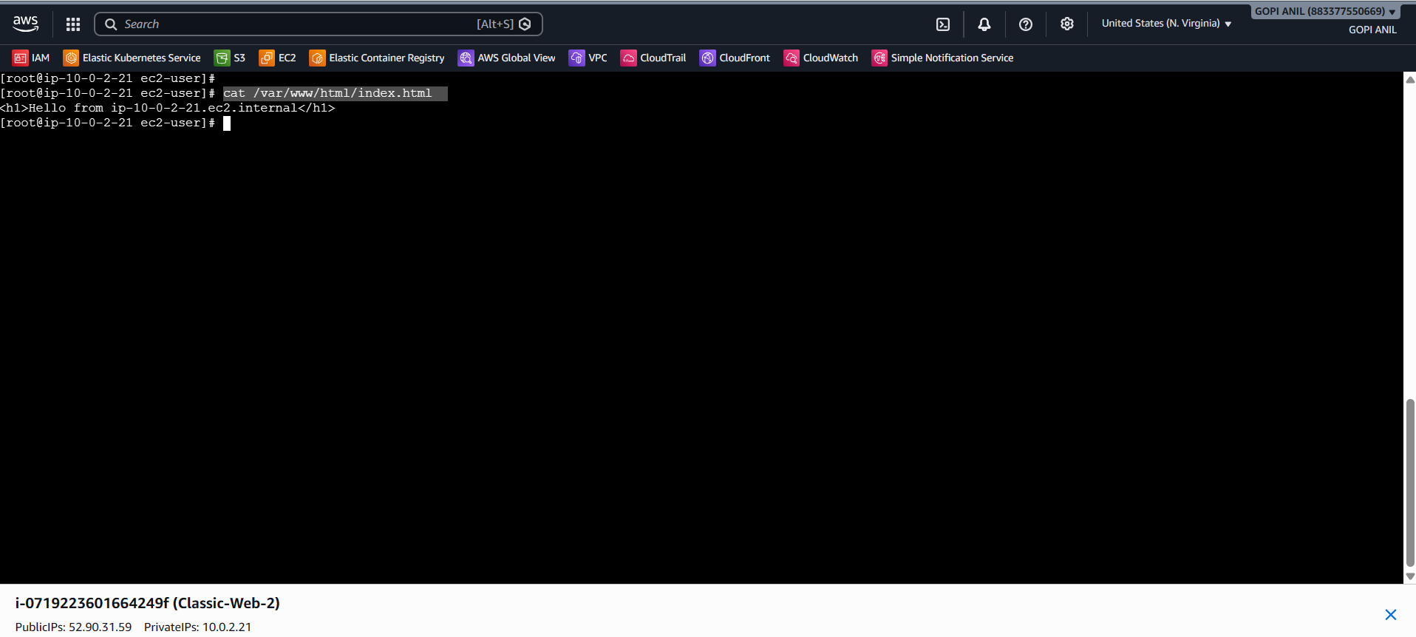

Step 1.4 — Create the Classic Load Balancer
1. EC2 console → Load Balancers → Create load balancer → under Classic Load Balancer, click Create.
2. Load Balancer name: Classic-LB-Demo. Scheme: internet-facing. IP address type: ipv4.
3. VPC: Lab-VPC. Availability Zones: check both, selecting Public-Subnet-A and Public-Subnet-B.
4. Listener: leave default HTTP:80 → HTTP:80. Click Next: Assign Security Groups.
5. Create a new security group named Classic-LB-SG with an inbound rule allowing HTTP (80) from 0.0.0.0/0.
6. Click Next: Configure Security Settings (the HTTPS warning is expected) → Next: Configure Health Check.
7. Ping Protocol: HTTP. Ping Port: 80. Ping Path: /. Leave the remaining defaults → Next: Add EC2 Instances.
8. Check Classic-Web-1 and Classic-Web-2 → Next: Add Tags (optional) → Review → Create.

Step 1.5 — Verify
1. Wait for the State column to show InService for both instances (select Classic-LB-Demo → Instances tab).
2. Copy the DNS name from the Description tab and open it in a browser; refresh a few times to confirm responses alternate between Classic-Web-1 and Classic-Web-2.
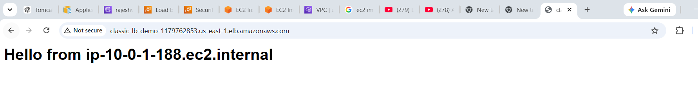
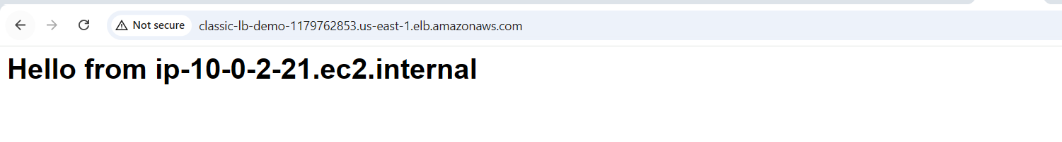

TASK 2: Configure an Application Load Balancer

Step 2.1 — Create a Security Group for the Backend Instances
1. EC2 console → Security Groups → Create security group.
2. Name: App-Backend-SG. VPC: Lab-VPC.
3. Inbound rules: allow HTTP (80) from Lab-VPC's CIDR (10.0.0.0/16).
4. Click Create security group.
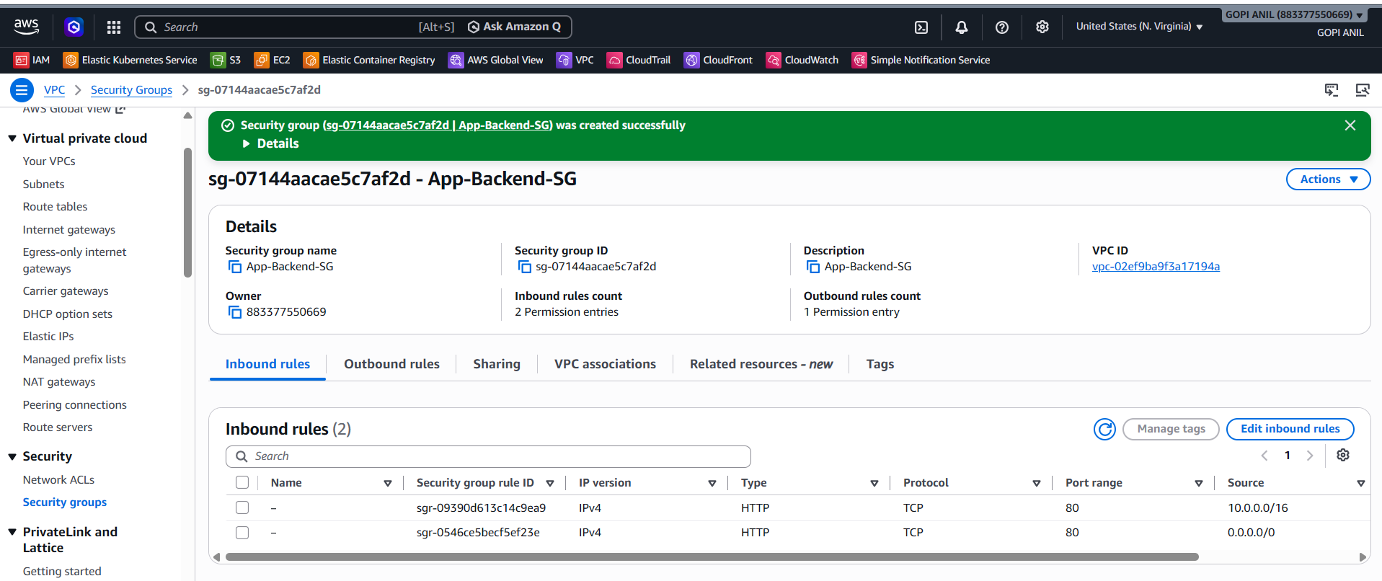

Step 2.2 — Launch Two Backend EC2 Instances
1. EC2 console → Instances → Launch instances.
2. Name: App-Web-1. AMI: Amazon Linux 2023. Instance type: t2.micro.
3. Network settings: VPC = Lab-VPC, Subnet = Public-Subnet-A, Auto-assign public IP = Enable, Security group = App-Backend-SG.
4. Click Launch instance.
5. Repeat, naming the second instance App-Web-2, placed in Public-Subnet-B.
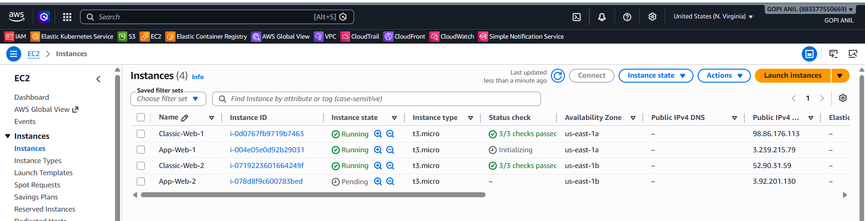

Step 2.3 — Install Apache on Both Instances
1. Connect to each instance and run:
sudo yum update -y
sudo yum install -y httpd
sudo systemctl enable --now httpd
echo "<h1>Hello from $(hostname -f)</h1>" | sudo tee /var/www/html/index.html
2. Confirm both instances show Running and pass EC2 status checks.
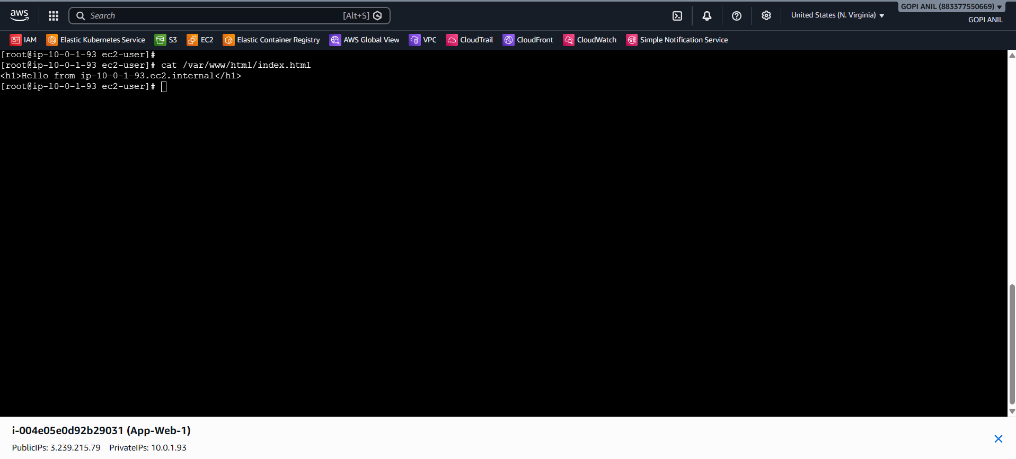
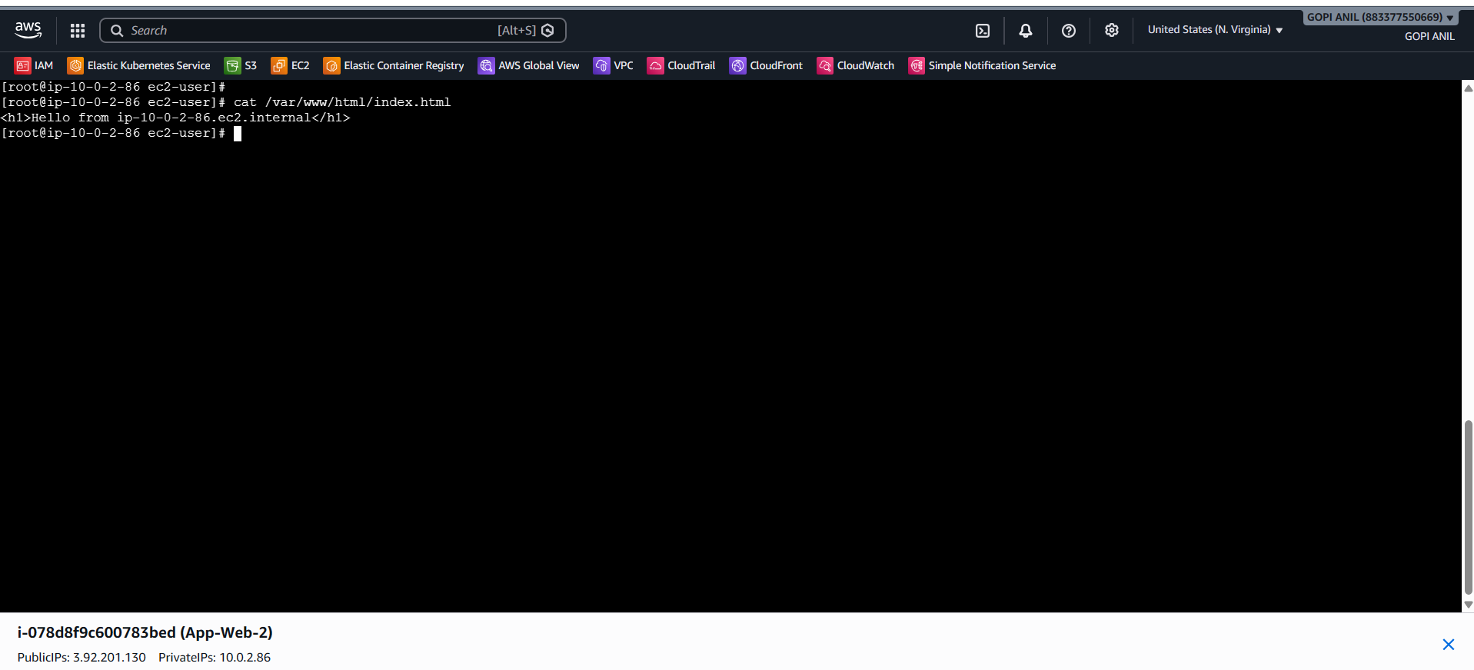

Step 2.4 — Create a Target Group
1. EC2 console → Target Groups → Create target group.
2. Target type: Instances. Name: App-Target-Group. Protocol: HTTP, Port: 80. VPC: Lab-VPC.
3. Health check path: / (default). Click Next.
4. Register targets: select App-Web-1 and App-Web-2 → Include as pending below → Create target group.
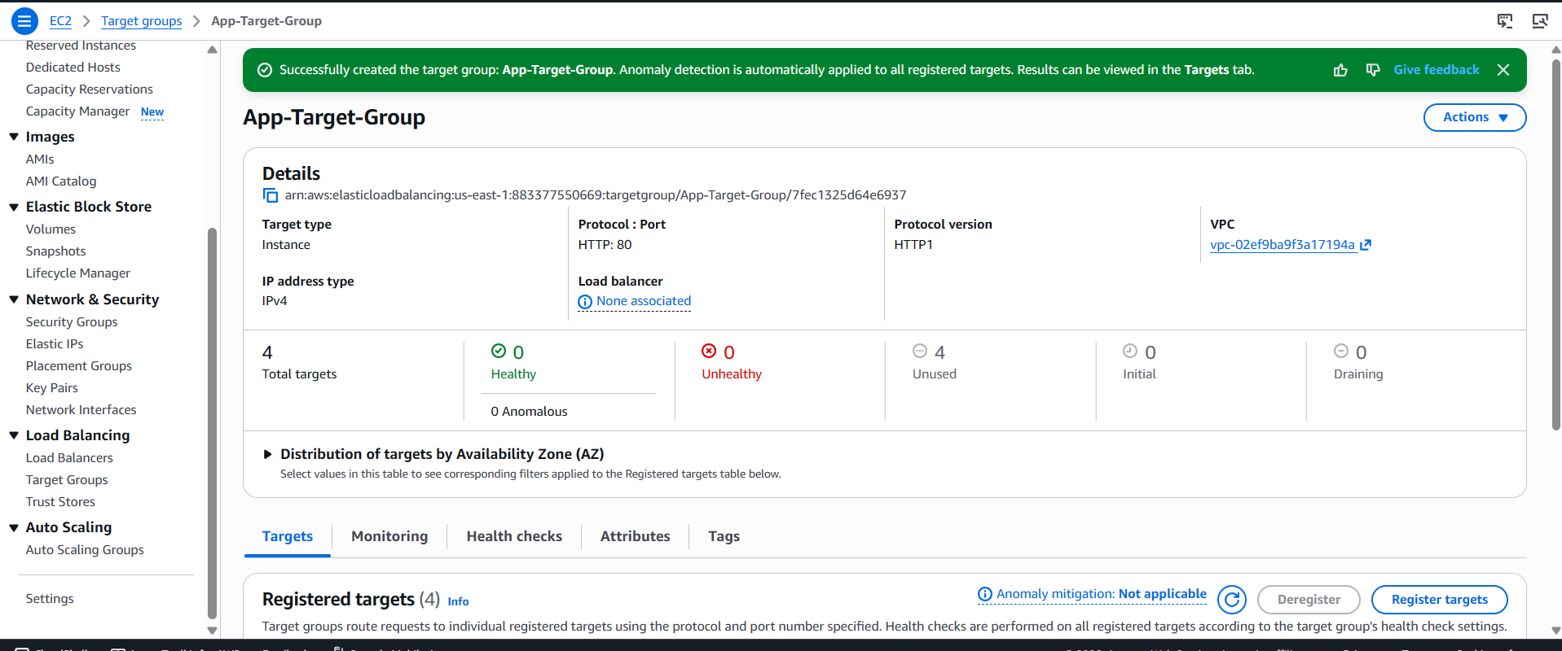

Step 2.5 — Create a Security Group for the ALB
1. EC2 console → Security Groups → Create security group. Name: App-ALB-SG. VPC: Lab-VPC.
2. Inbound rules: Allow HTTP (80) from 0.0.0.0/0 (HTTPS (443) is added in Task 4).
3. Click Create security group.
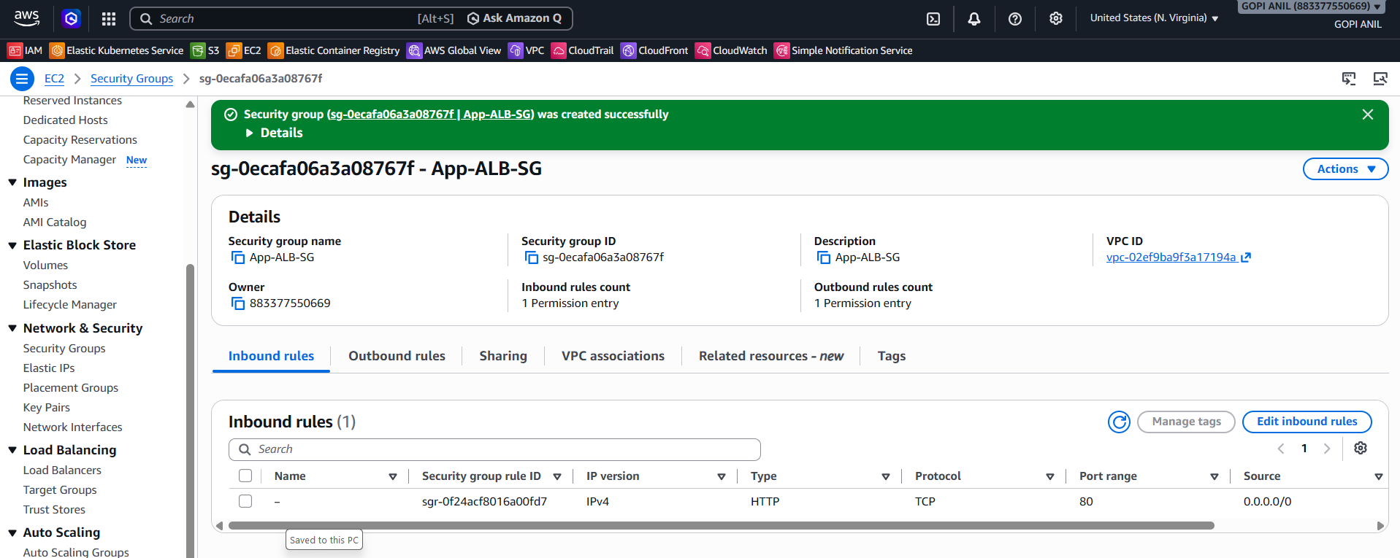

Step 2.6 — Create the Application Load Balancer
1. EC2 console → Load Balancers → Create load balancer → Application Load Balancer → Create.
2. Name: App-ALB-Demo. Scheme: Internet-facing. IP address type: IPv4.
3. Network mapping: VPC = Lab-VPC; select both Public-Subnet-A and Public-Subnet-B.
4. Security groups: select App-ALB-SG.
5. Listeners and routing: Listener HTTP:80 → Default action: forward to App-Target-Group.
6. Click Create load balancer. Wait for State = Active.
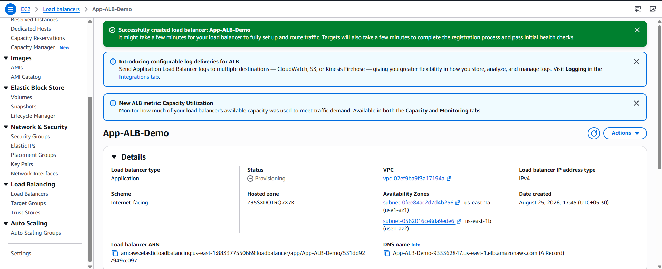

Step 2.7 — Verify
1. Target Groups → App-Target-Group → Targets tab → confirm both instances show Health status = healthy.
2. Copy the ALB's DNS name and open it in a browser; refresh a few times to confirm both backend servers respond.

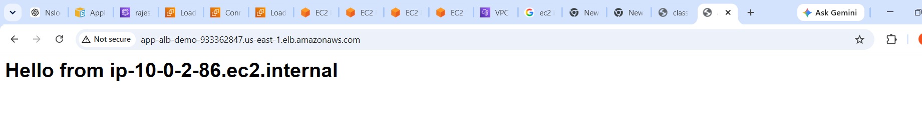
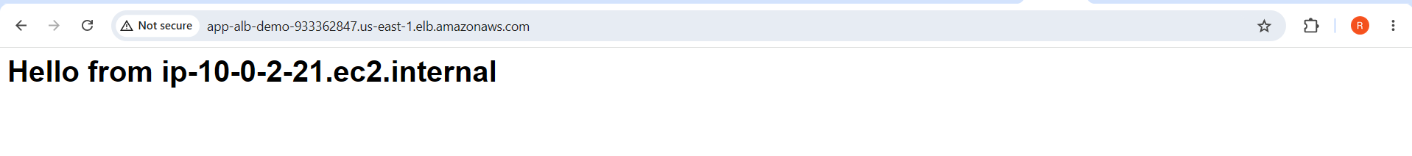

TASK 3: Configure a Network Load Balancer
The Network Load Balancer (NLB) operates at Layer 4 (TCP/UDP/TLS), offering ultra-low latency, static IP addresses per AZ, and no security group of its own — traffic control happens at the target/instance security group instead.

Step 3.1 — Create a Security Group for the Backend Instances
1. EC2 console → Security Groups → Create security group.
2. Name: Net-Backend-SG. VPC: Lab-VPC.
3. Inbound rules: allow TCP port 80 from 0.0.0.0/0 (since an NLB has no security group of its own and preserves the client's source IP by default, the backend SG must allow the traffic directly).
4. Click Create security group.
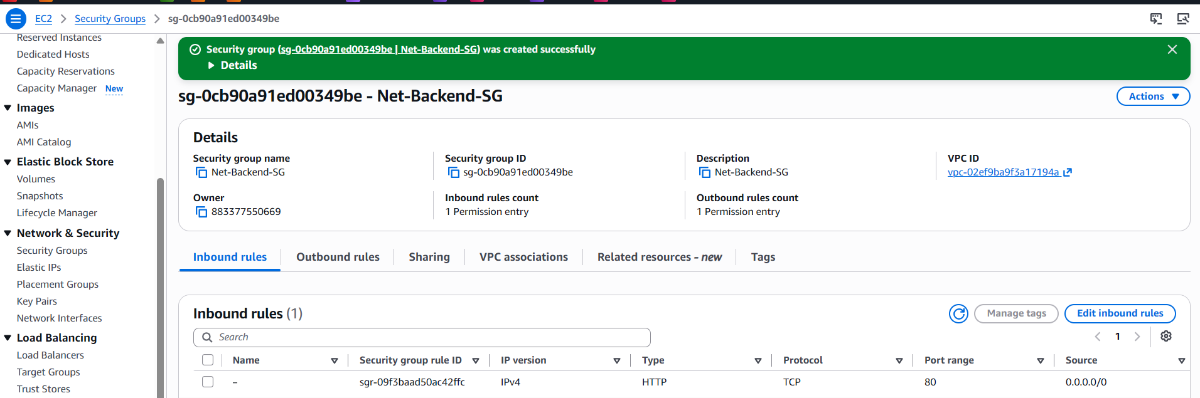

Step 3.2 — Launch Two Backend EC2 Instances
1. EC2 console → Instances → Launch instances.
2. Name: Net-Web-1. AMI: Amazon Linux 2023. Instance type: t2.micro.
3. Network settings: VPC = Lab-VPC, Subnet = Public-Subnet-A, Auto-assign public IP = Enable, Security group = Net-Backend-SG.
4. Click Launch instance.
5. Repeat, naming the second instance Net-Web-2, placed in Public-Subnet-B.

Step 3.3 — Install Apache on Both Instances
1. Connect to each instance and run:
sudo yum update -y
sudo yum install -y httpd
sudo systemctl enable --now httpd
echo "<h1>Hello from $(hostname -f)</h1>" | sudo tee /var/www/html/index.html
2. Confirm both instances show Running and pass EC2 status checks.
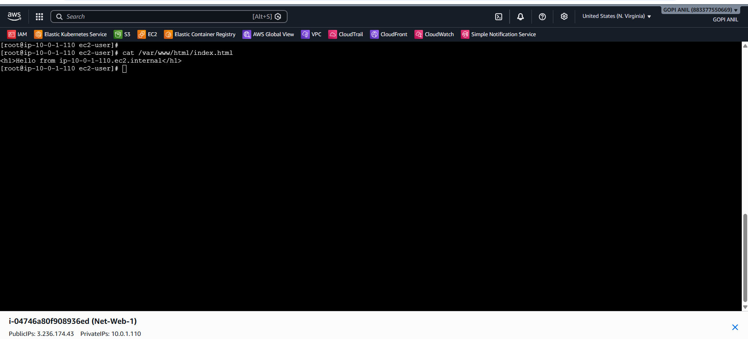
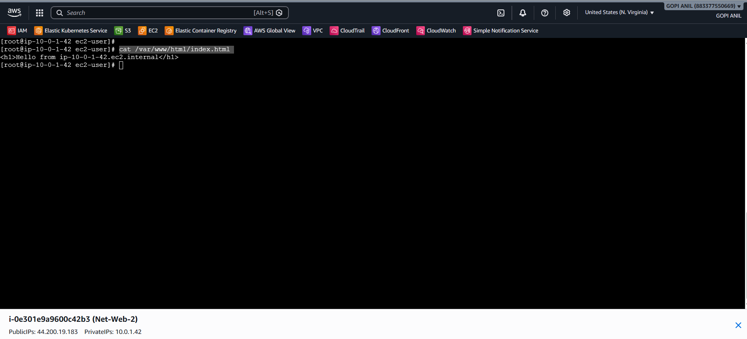

Step 3.4 — Create a Target Group for the NLB
1. EC2 console → Target Groups → Create target group.
2. Target type: Instances. Name: Net-Target-Group. Protocol: TCP, Port: 80. VPC: Lab-VPC.
3. Health check protocol: TCP (or HTTP with path / for an application-aware check). Click Next.
4. Register targets: select Net-Web-1 and Net-Web-2 → Include as pending below → Create target group.
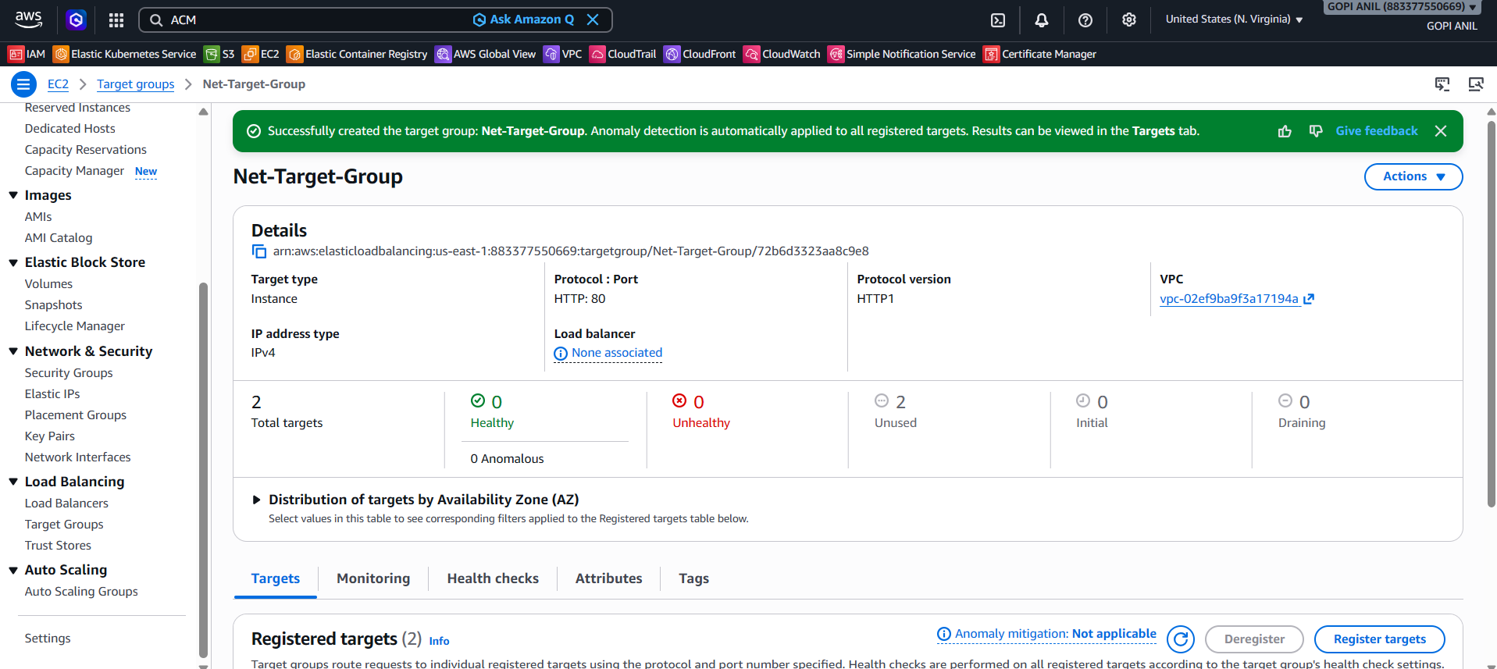

Step 3.5 — Create the Network Load Balancer
1. EC2 console → Load Balancers → Create load balancer → Network Load Balancer → Create.
2. Name: Net-NLB-Demo. Scheme: Internet-facing. IP address type: IPv4.
3. Network mapping: VPC = Lab-VPC; select both Public-Subnet-A and Public-Subnet-B; optionally assign a specific Elastic IP per zone for a fixed, predictable public IP.
4. Listeners and routing: Listener TCP:80 → Default action: forward to Net-Target-Group.
5. Click Create load balancer. Wait for State = Active.
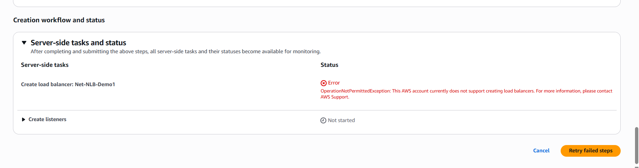

Step 3.6 — Verify
1. Target Groups → Net-Target-Group → Targets tab → confirm both instances show Health status = healthy.
2. Copy the NLB's DNS name and open it in a browser; refresh to confirm both backend servers respond.

TASK 4: Attach SSL for the Application Load Balancer
This task adds HTTPS to App-ALB-Demo, created in Task 2, and relies on the Route 53 hosted zone created in Phase 2 to validate the certificate.

Step 4.1 — Request a Public Certificate in ACM
1. Open the AWS Certificate Manager (ACM) console in the SAME Region as App-ALB-Demo (us-east-1) — ACM certificates used by an ALB must be requested in that ALB's own Region.
2. Request → Request a public certificate → Next.
3. Fully qualified domain name: enter app.mylabsite2026.com. Optionally add another name, e.g., www.app.mylabsite2026.com.
4. Validation method: DNS validation → Request.
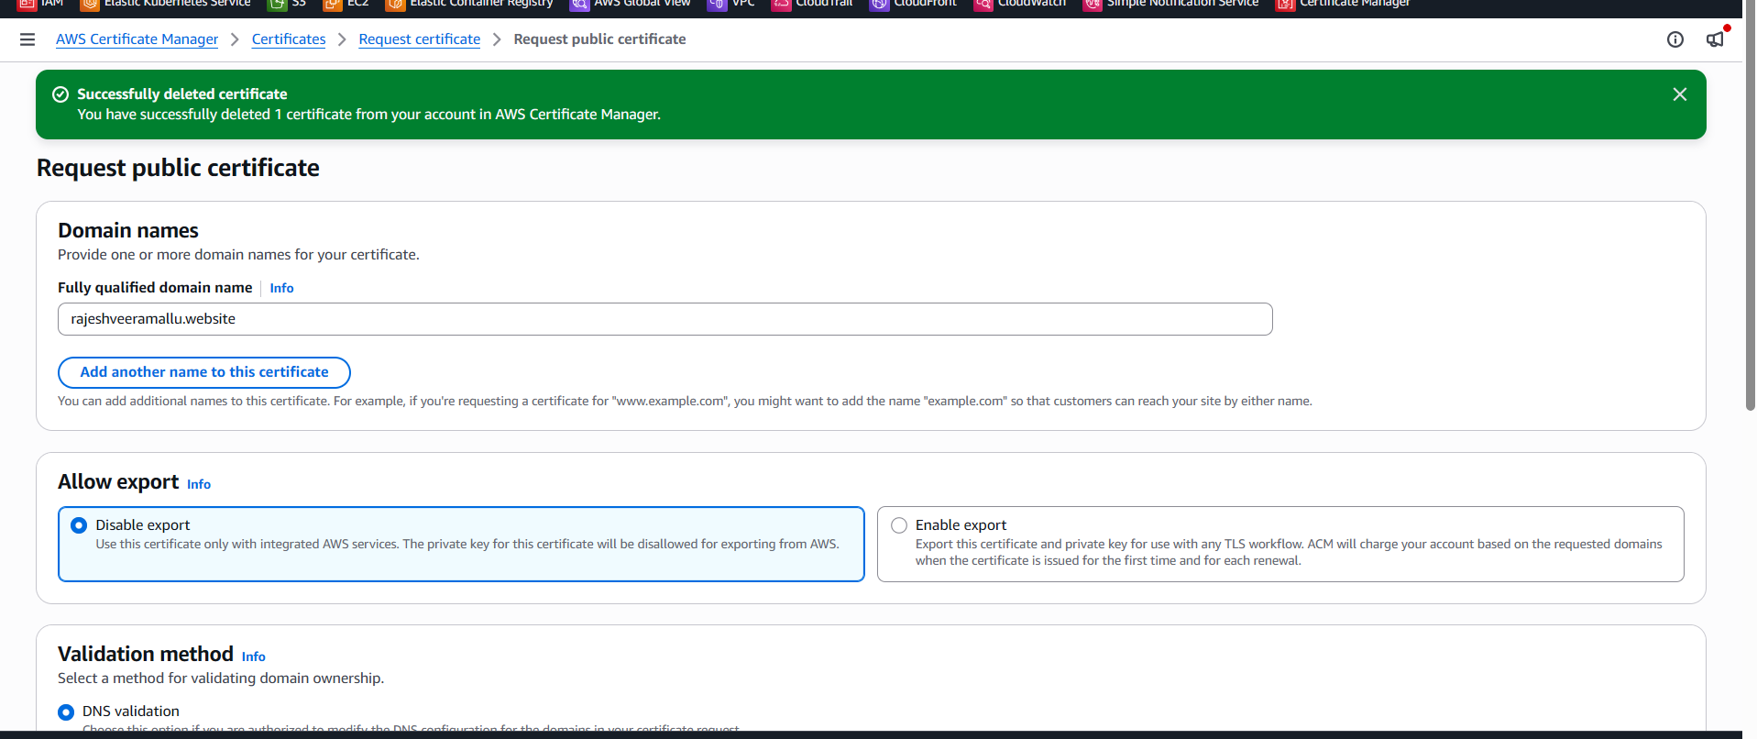

Step 4.2 — Validate the Certificate via Route 53
1. Open the new certificate → note the CNAME name and CNAME value shown under Domains.
2. Since the hosted zone from Phase 2 is already in Route 53, click Create records in Route 53 directly from the ACM console for one-click validation.
3. Wait for the certificate Status to change from Pending validation to Issued (a few minutes up to a few hours).
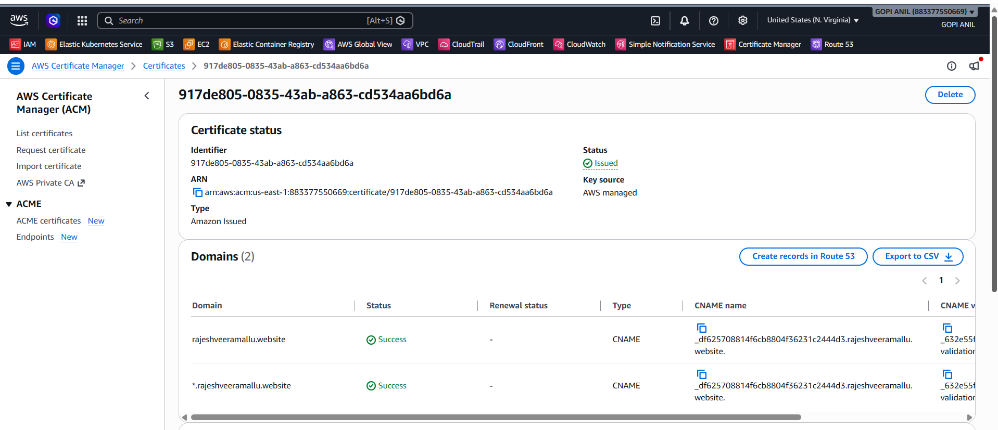

Step 4.3 — Add an HTTPS Listener to the ALB
1. EC2 console → Load Balancers → select App-ALB-Demo → Listeners tab → Add listener.
2. Protocol: HTTPS. Port: 443. Default action: forward to App-Target-Group.
3. Security policy: leave the recommended default (e.g., ELBSecurityPolicy-TLS13-1-2-2021-06).
4. Default SSL/TLS certificate: select From ACM → choose the certificate issued in Step 4.2.
5. Click Add.
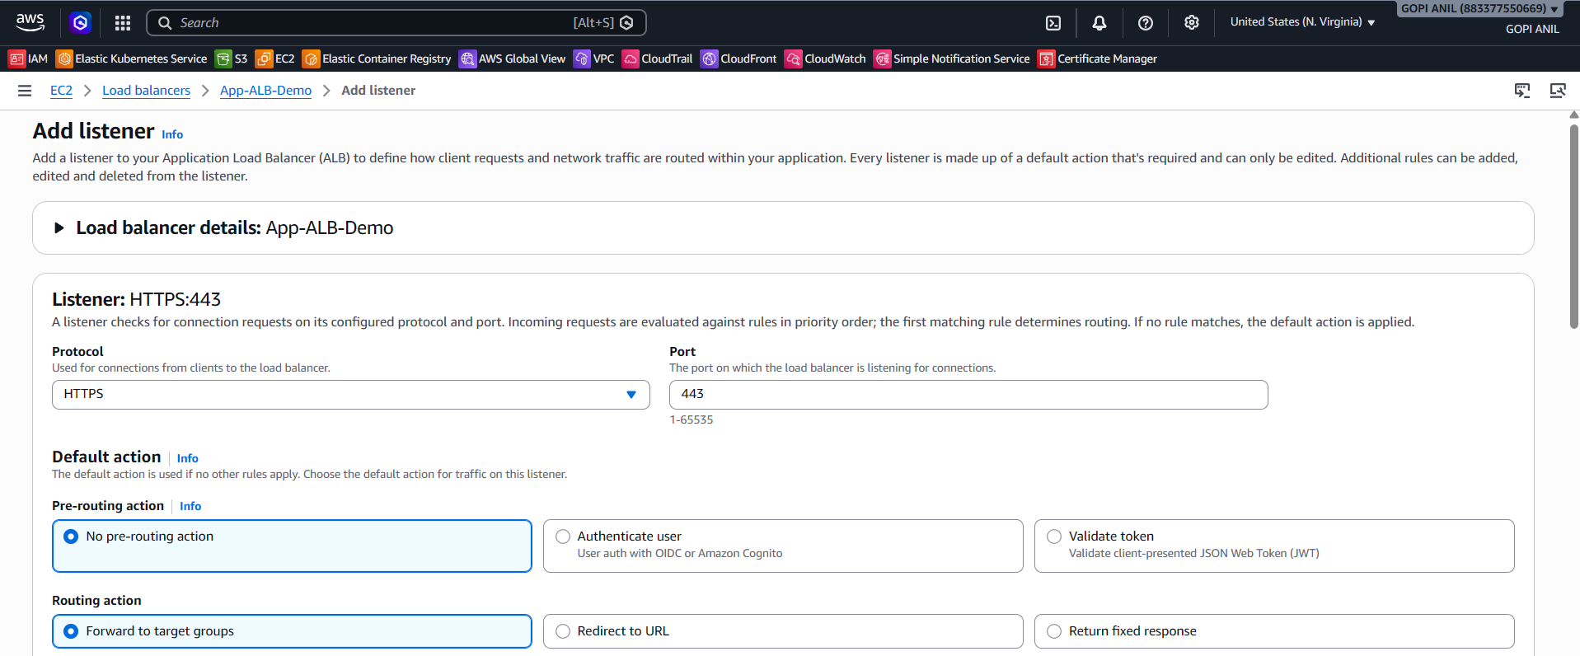
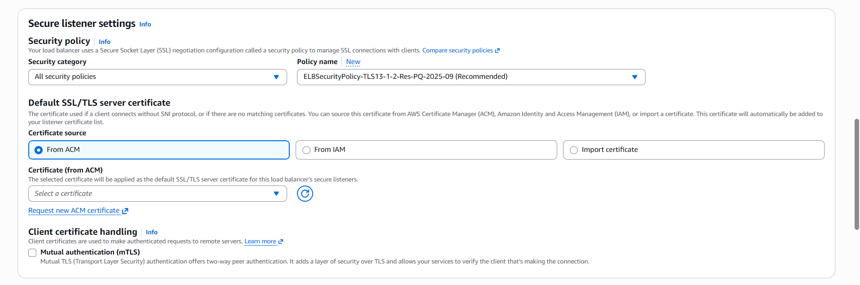
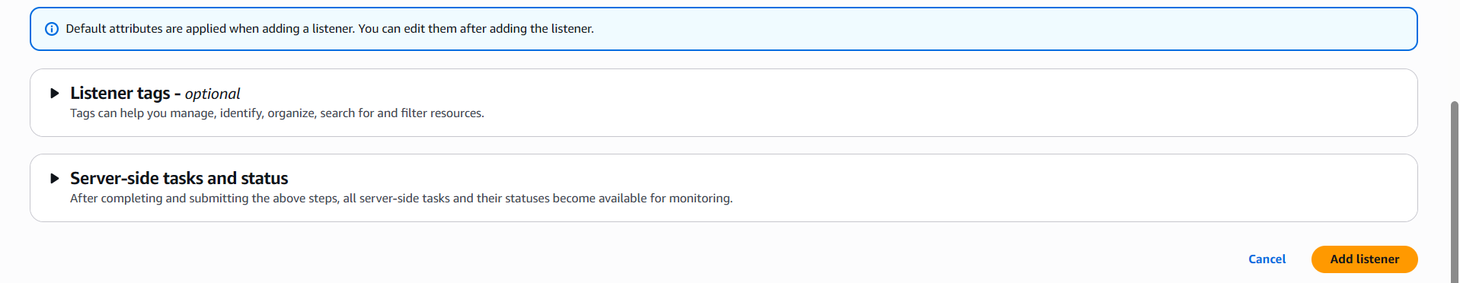

Step 4.4 — Allow HTTPS Through the ALB's Security Group
1. EC2 console → Security Groups → select App-ALB-SG → Inbound rules → Edit inbound rules.
2. Add rule: HTTPS (443) from 0.0.0.0/0 → Save rules.
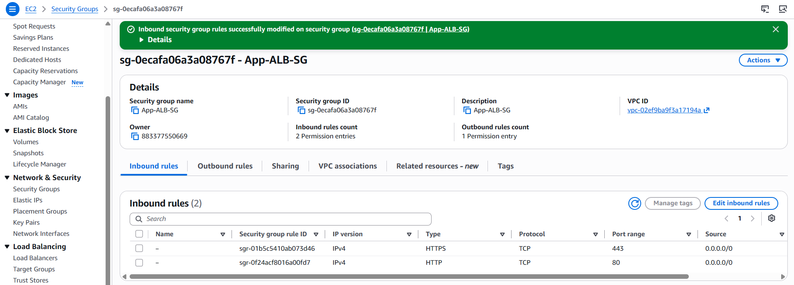

Step 4.5 — Verify
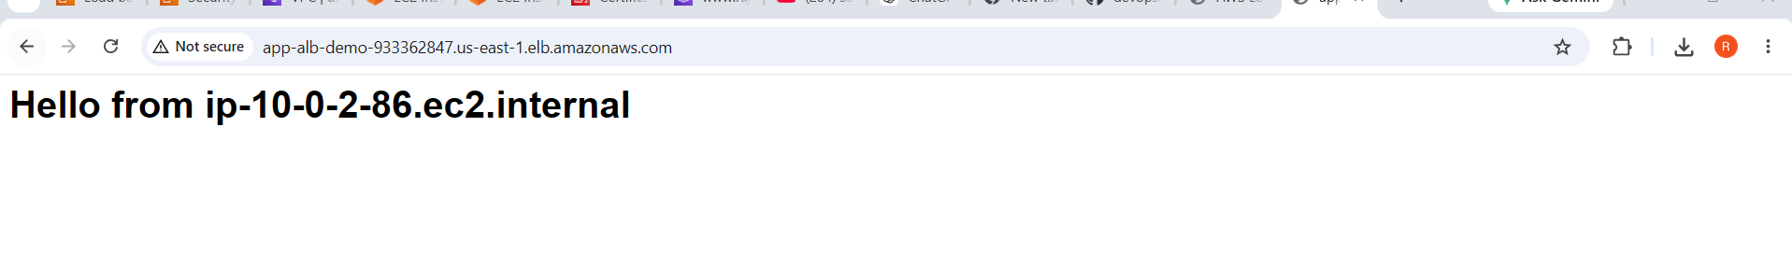

TASK 5: Map the Application Load Balancer to Route 53
This task points the GoDaddy-registered domain (onboarded to Route 53 in Phase 2) at App-ALB-Demo (created in Task 2, with HTTPS from Task 4).

Step 5.1 — Open the Hosted Zone
1. Route 53 console → Hosted zones → select mylabsite2026.com (created in Phase 2).
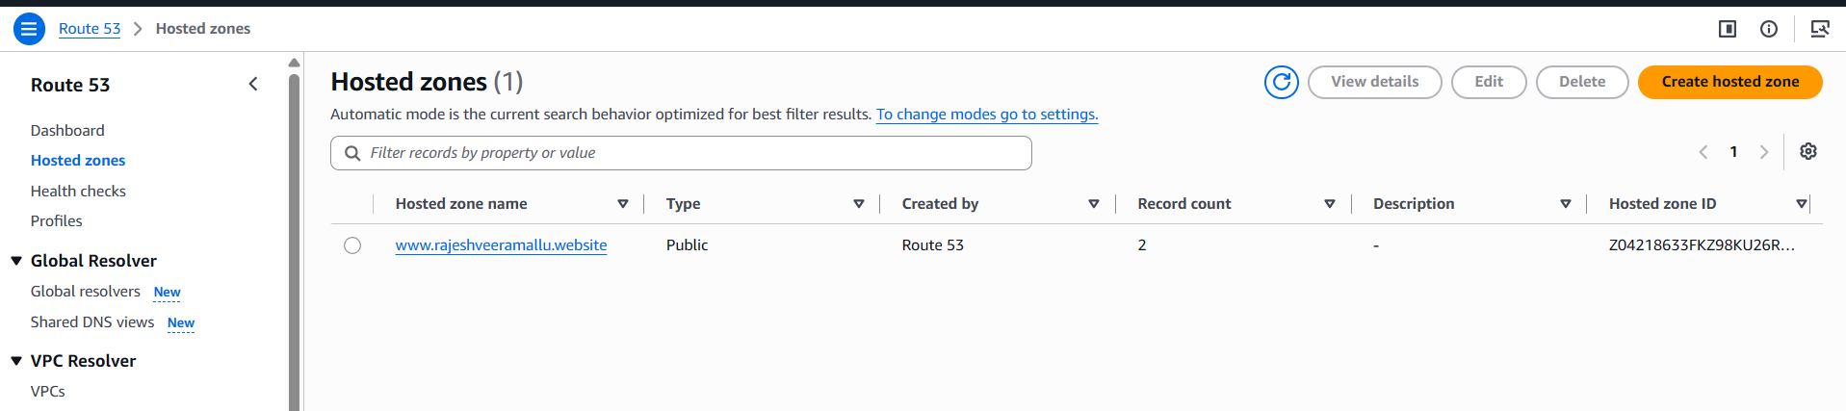

Step 5.2 — Create an Alias Record to the ALB
1. Click Create record.
2. Record name: app (creates app.mylabsite2026.com, matching the certificate name from Task 4).
3. Record type: A.
4. Toggle Alias to ON.
5. Route traffic to: Alias to Application and Classic Load Balancer.
6. Choose Region: us-east-1.
7. Choose App-ALB-Demo from the load balancer dropdown.
8. Click Create records.
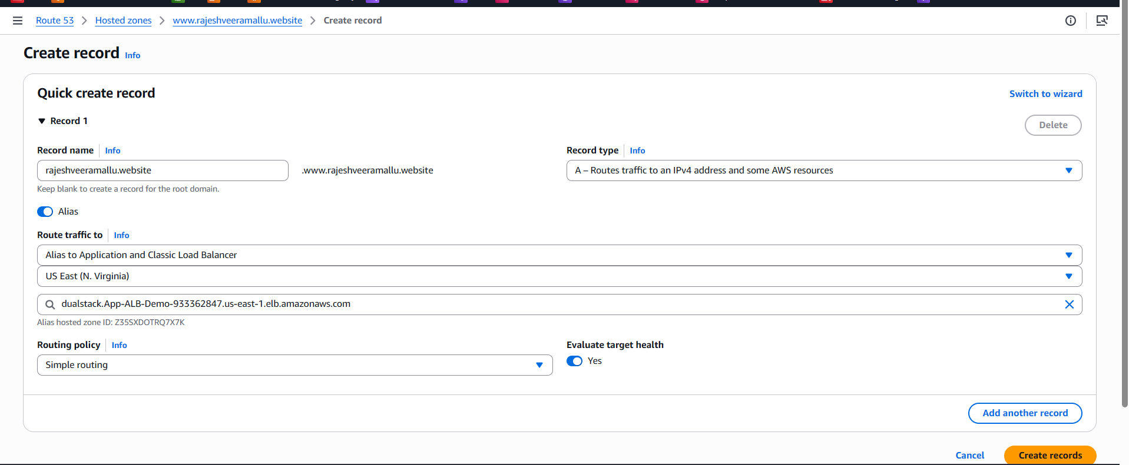

Step 5.3 — Verify
1. Wait a few minutes for propagation, then run: dig app.mylabsite2026.com and confirm it resolves to the ALB's IP addresses.
2. Open https://app.mylabsite2026.com in a browser and confirm the site loads over HTTPS using the custom domain, alternating between App-Web-1 and App-Web-2 on refresh.
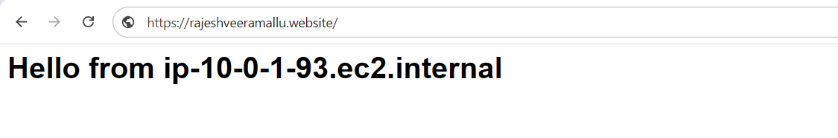

TASK 6: Push the Application Load Balancer Logs to S3
This task enables access logging on App-ALB-Demo, created in Task 2.

Step 6.1 — Create the Logs Bucket
1. S3 console → Create bucket.
2. Bucket name: rajeshveeramallu.website
3. Region: us-east-1 — must match where App-ALB-Demo runs.
4. Leave Block all public access ON. Click Create bucket.
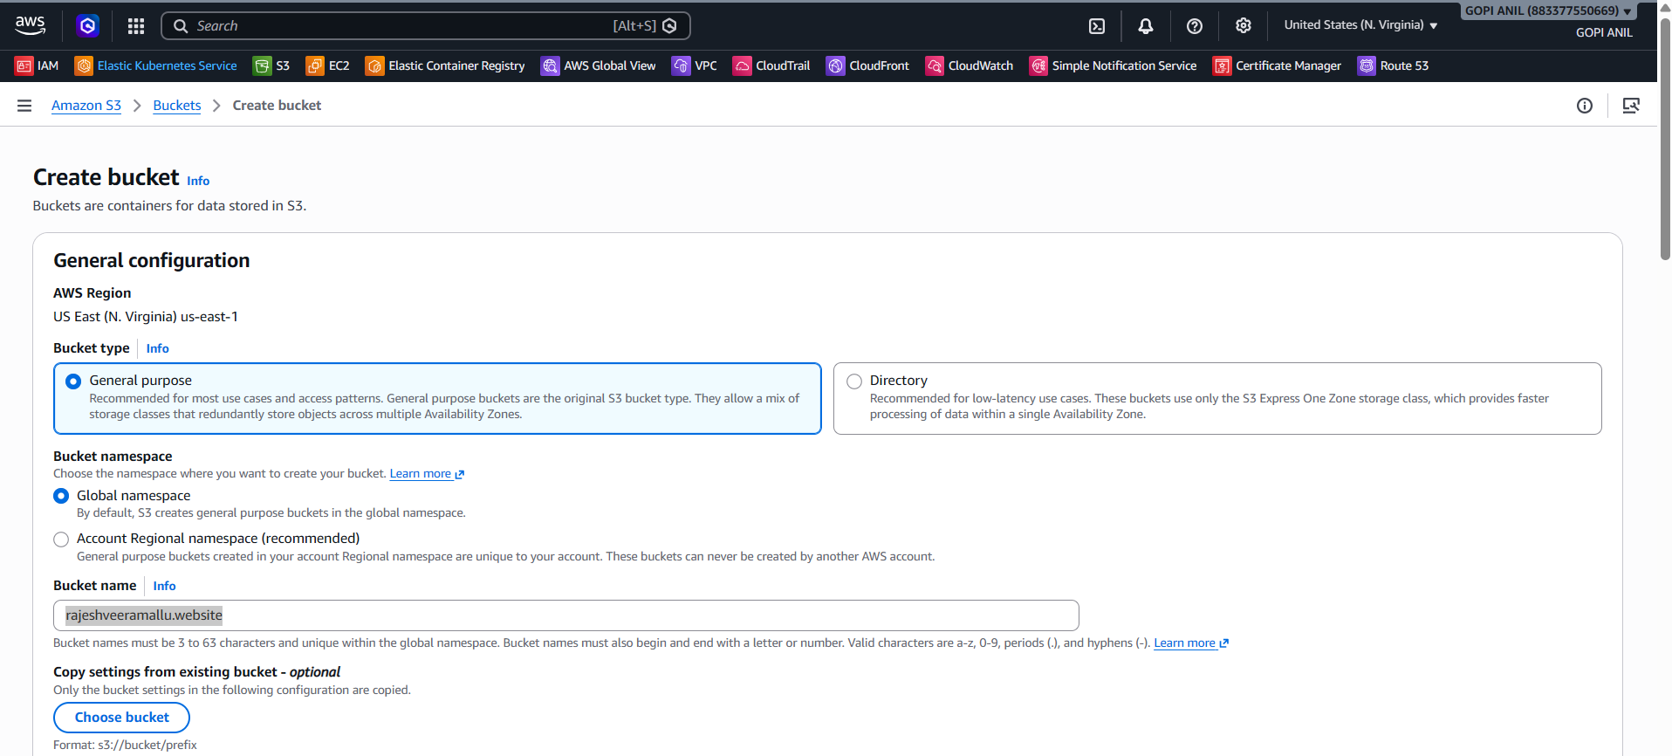
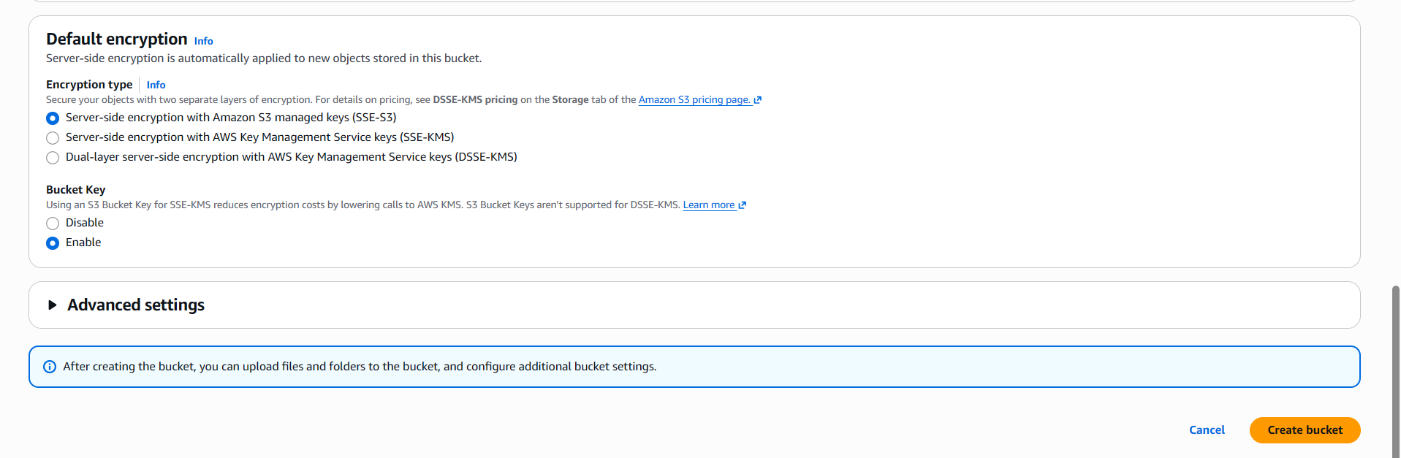

Step 6.2 — Attach a Bucket Policy Allowing the ELB Service to Write Logs
1. Select the bucket → Permissions tab → Bucket policy → Edit.
2. Paste the policy below. The Principal account ID (127311923021) is AWS's fixed Elastic Load Balancing log-delivery account for us-east-1 — verify the correct ID for other Regions in the AWS documentation:
{
"Version": "2012-10-17",
"Statement": [
{
"Effect": "Allow",
"Principal": {
"Service": "logdelivery.elasticloadbalancing.amazonaws.com"
},
"Action": "s3:PutObject",
"Resource": "arn:aws:s3:::lab-app-alb-access-logs-2026/AWSLogs/883377550669/*"
}
]
}
3. Click Save changes.
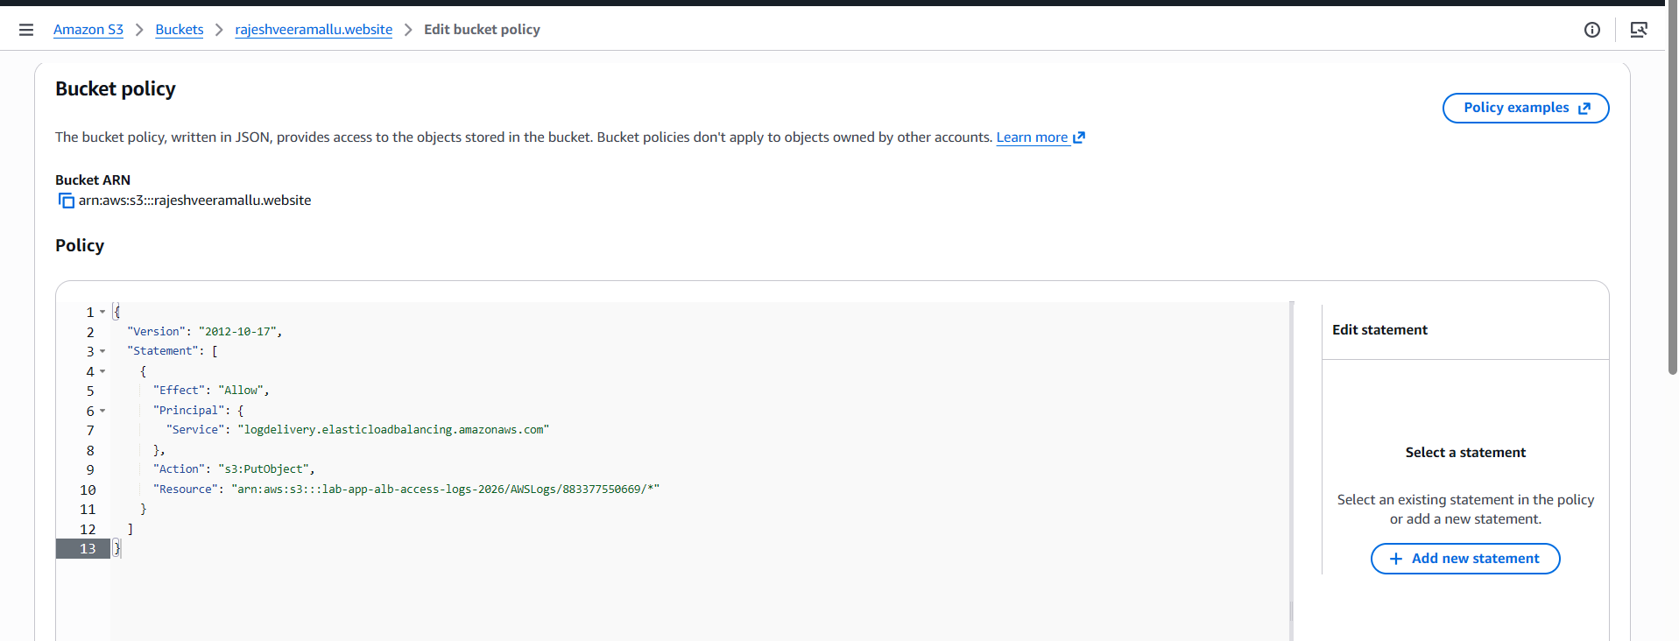

Step 6.3 — Enable Access Logging on the ALB
1. EC2 console → Load Balancers → select App-ALB-Demo → Attributes tab → Edit.
2. Monitoring → Access logs: toggle On.
3. S3 URI: s3://lab-app-alb-access-logs-2026 (optionally add a prefix, e.g., s3://lab-app-alb-access-logs-2026/app-alb).
4. Click Save changes.
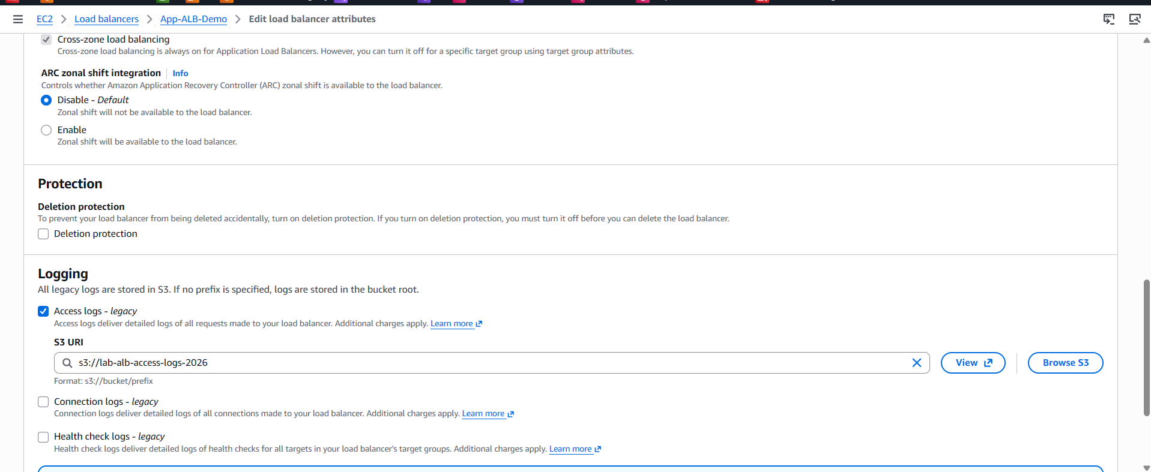

Step 6.4 — Verify
